# **EXTEND THE CAPABILITY**

# **Step 1: Collecting Time-Series Data**

## Problem

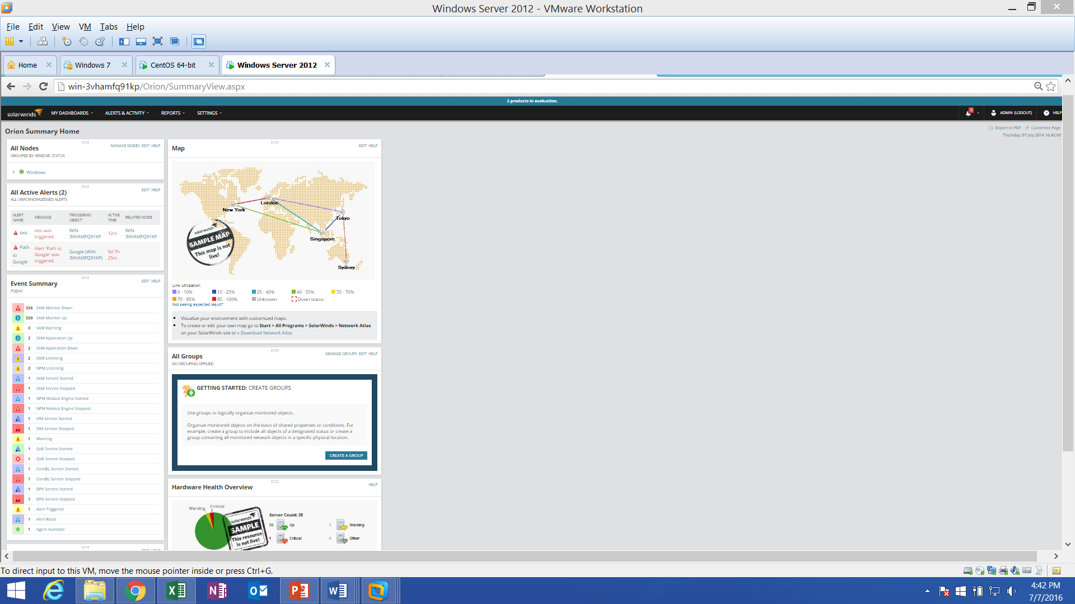

## Solution

